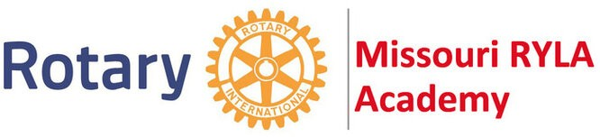

University of Central Missouri, Warrensburg

**Rotary Youth Leadership Award Application**

Applicant Name: ___________

Mailing Address: ___________________

Email Address: ___________________________________________________________________________

Phone: Birth date: _________ M or F (circle one)

Name of High School: __________________

Extra-Curricular Activities/ Hobbies (attach additional sheet if necessary):

Parent/Guardian Name: ___________ Phone: ___________________

Email Address: ___________________

Circle the session you choose to attend (only one session per applicant will be awarded):

Session 1: Sunday, June 23rd thru Wednesday, June 26th
Session 2: Sunday, July 7th thru Wednesday, July 10th

Adult Tee Shirt Size: (circle one) S—M—L—XL—XXL

Student Signature Parent/Guardian Signature

After completely filling out this application, please return it to Ashley Walden via email.

Completed applications are being accepted now but must be received no later than January 1, 2024.

Sponsoring Rotary Club: Southeast Rotary of Springfield

Contact Rotarian: Ashley Walden Phone: 417.848.5122 Email: awalden06@gmail.com

